Juice Recipes

Green Machine.
Improved digestion, aids weight loss , reduce inflammation and boost immunity
Ingredients  Bunch of Kale  2 Green Apples  1 Cucumber  2 Sticks of Celery  Pinch of fresh Parsley  Instructions  Juice it all up | 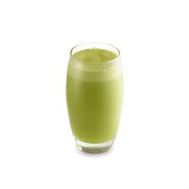

Carrot Energizer

Refreshing and healthy carrot apple ginger juice is not only energizing but easy to prepare as well. This fruit and vegetable juice is rich in multivitamins, beta-carotenes and antioxidants that cleans digestive system from toxins as well as helps body fight against cancer and many other diseases.
Ingredients
3 Carrots
2 Apples
1 Inch of Ginger
Instructions
Juice it all up

Cleanser

Apple ginger juice is one such healthy recipe which combines the best of both the worlds. The body warming effect of ginger gives your body an immunity to fight with common flu and cold while apple gives healthy dose of dietary fiber, which helps prevent absorption of dietary LDL cholesterol.
Ingredients  ½ Lemon  2-3 Apples  1 Inch of Ginger  Instructions  Juice it all up | 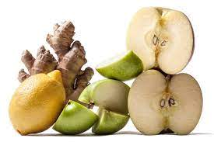

Fired up

Apple will perk you up with its sweetness and nutrients, Beetroot is a great blood cleanser and great for the heart and Celery is full of nutrients to help rehydrate the body again.
Ingredients  2 Red Apples  2 Sticks Celery  2 Raw Beetroots  Instructions  Juice it up | 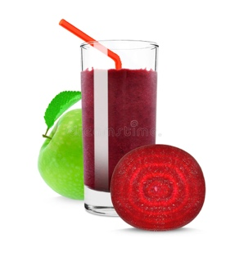

Detox
Green juice cleanses and detoxifies the body and provides the body with oxygen.
Ingredients  2 large handfuls of Spinach  Handful of Kale  3 Pears  ½ Lemon  1 Cucumber  Pinch of fresh Parsley  ½ Inch Ginger  Instructions  Juice it up | 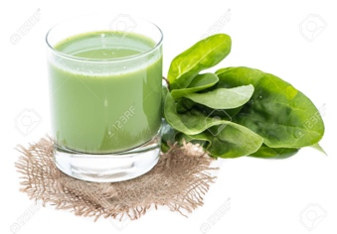

Tropical
Pineapple and Kale Juice Benefits Fresh kale provides vitamin A, vitamin K, C, B6, calcium, potassium and magnesium just to name a few. Some of the best pineapple juice benefits are: anti-inflammatory properties, vitamin C, gut and heart health.
Ingredients  ½ Pineapple  Handful of Kale  2 Pears  2 Sticks of Celery  Slice of Banana  Instructions  Juice it up | 